**STEP WISE DEMO FOR PROMT QUIZ**

**Step 1: Here is the interface of the Quizizz after you login, where click on the Create New Content to start a new Quiz.**

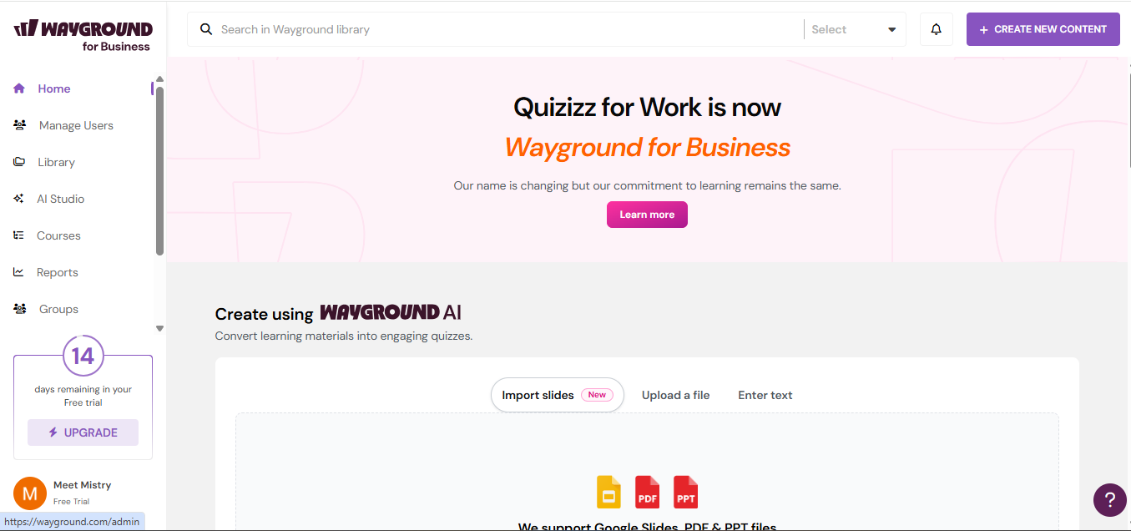

**Step 2: Select Create quiz using AI where u can use prompt or any document with the help of AI.**

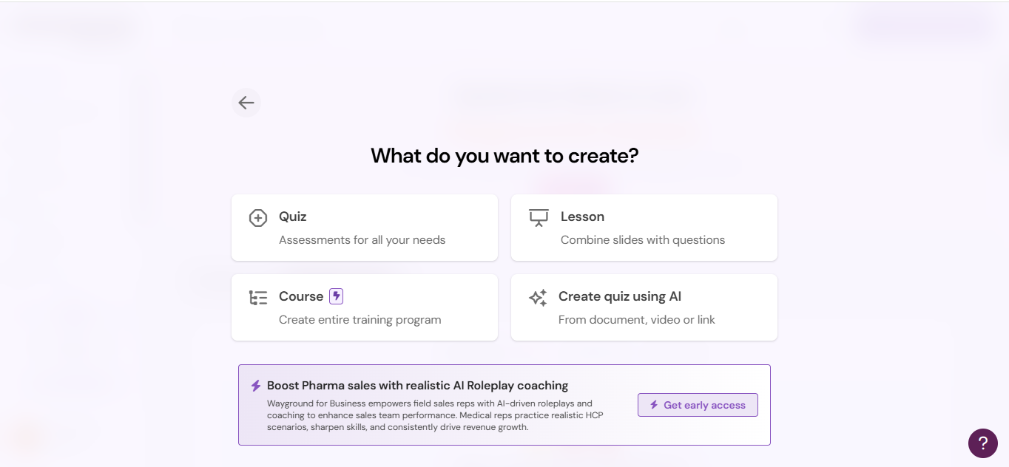

**Step 3: Select a Prompt field to start with a quiz using prompt.**

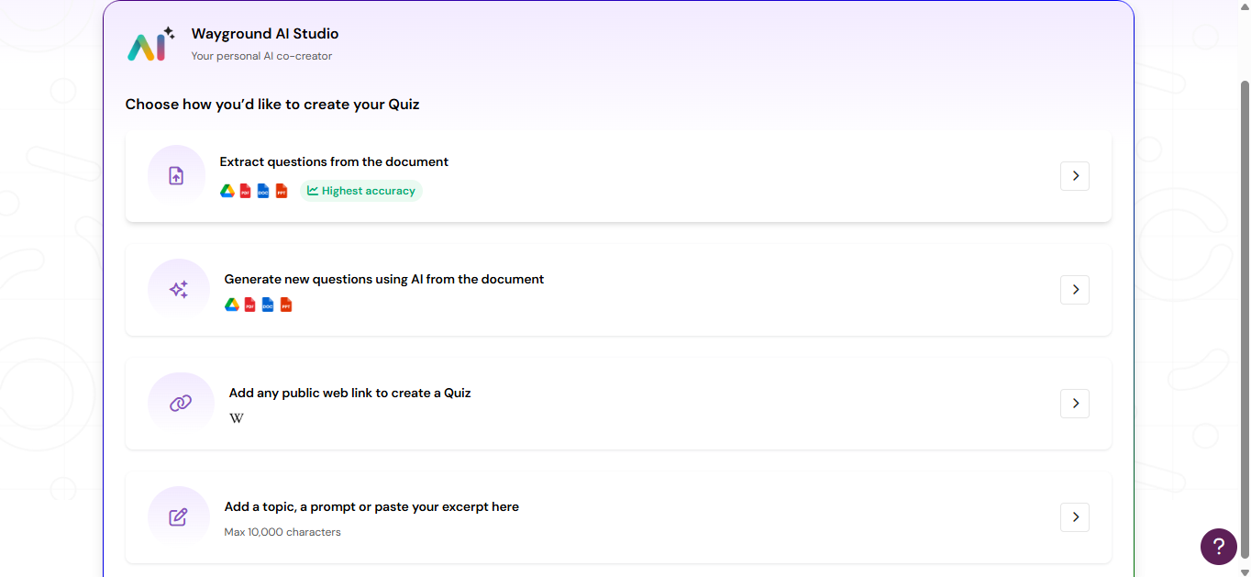

**Step 4: You can now write any topic of which you want to generate a Quiz for example I have written to create a Quiz on C and C++ programming language, and then click on generate quiz.**

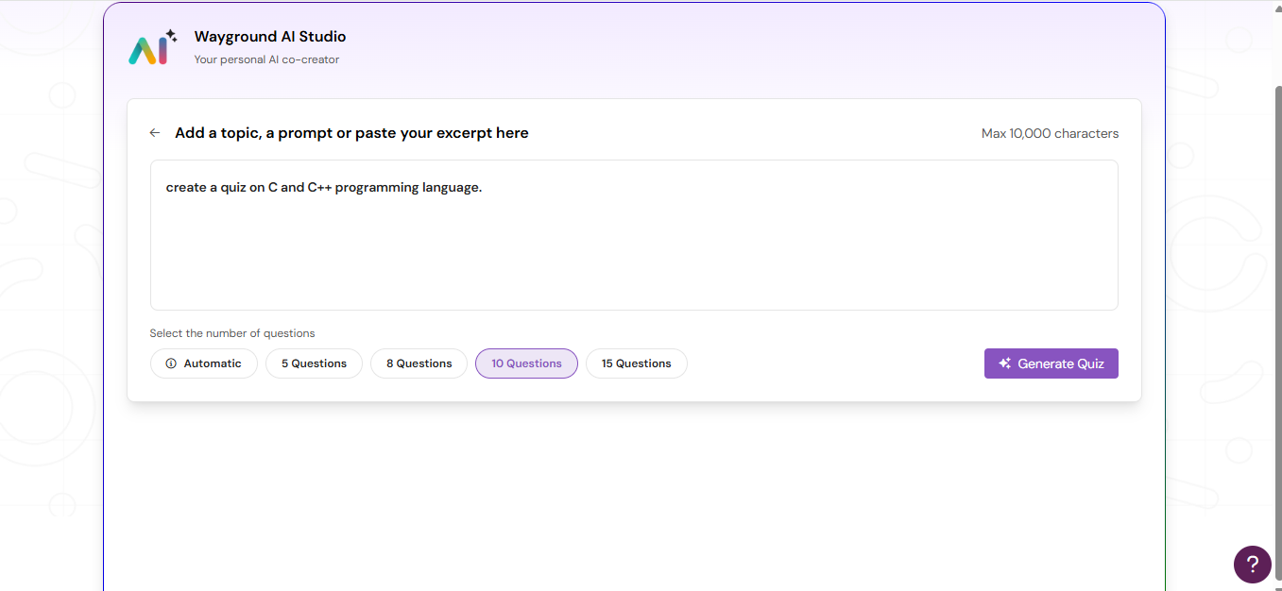

**Step 5: Quiz is now generating…**

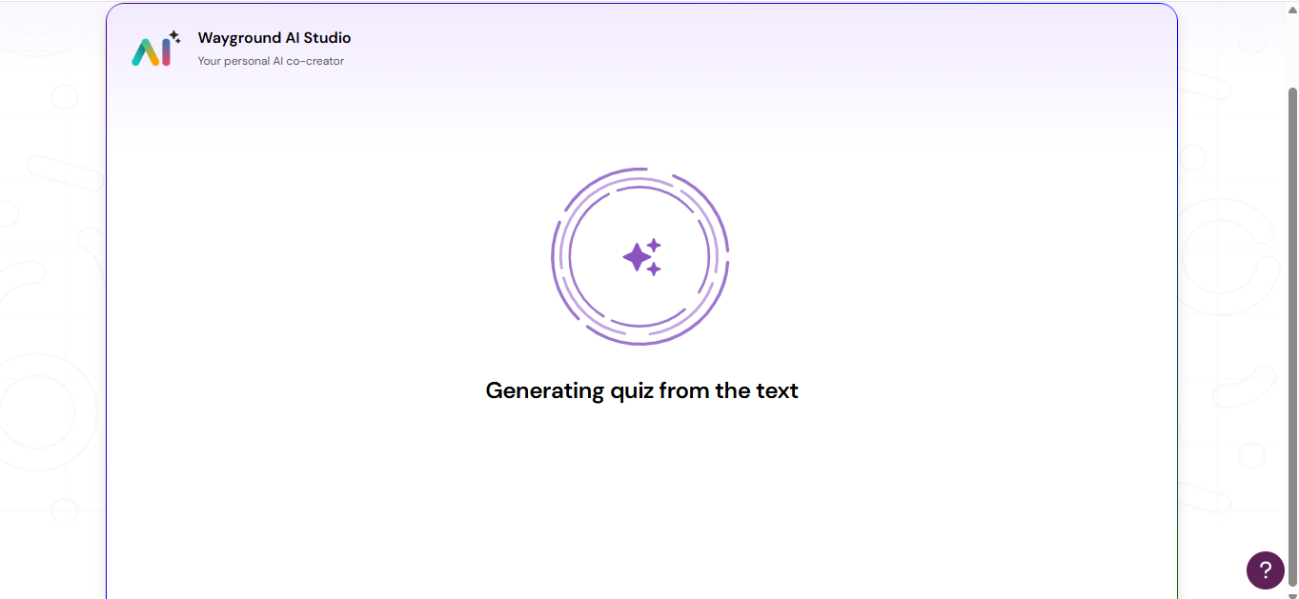

**Step 6: Once your quiz is generate here shows the interface how your quiz looks like, there are many editable options given as well..**

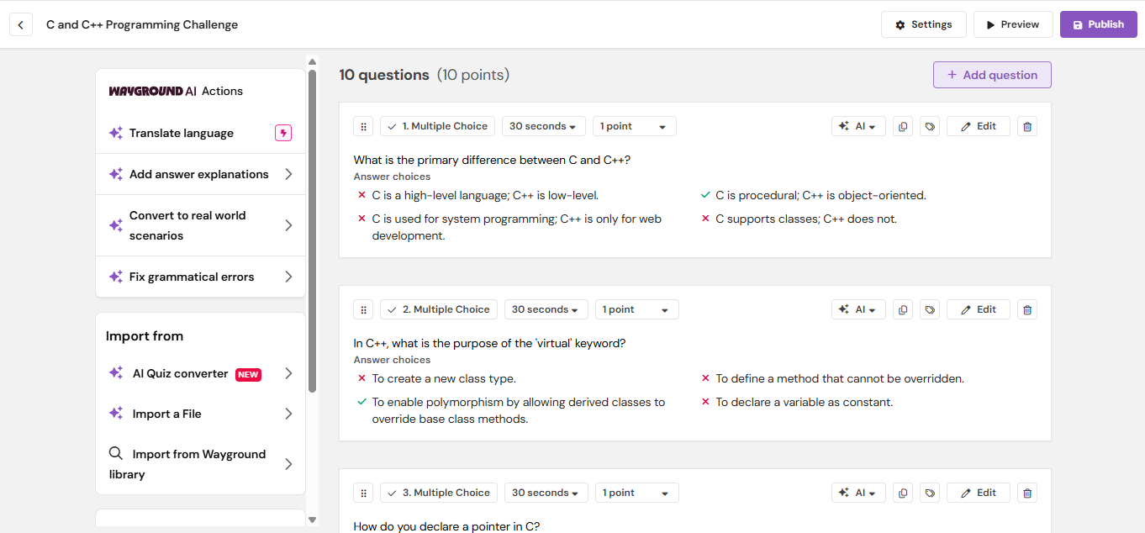

**Step 7: Here you can even add any extra question as well or click to the Publish**

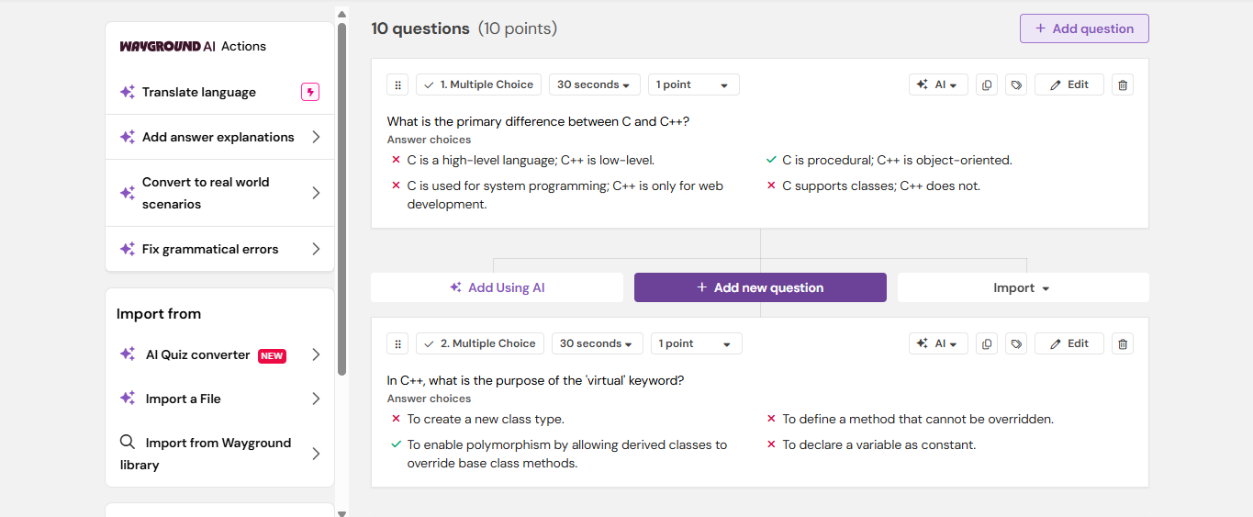

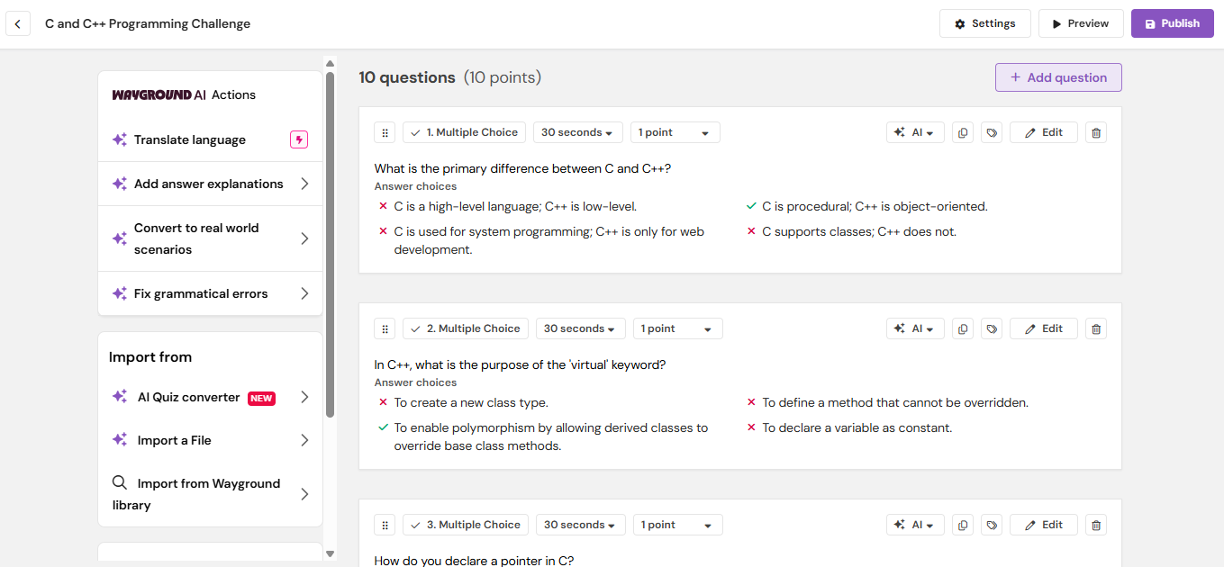

**Step 8: Now select to the Start live session now to start your quiz**

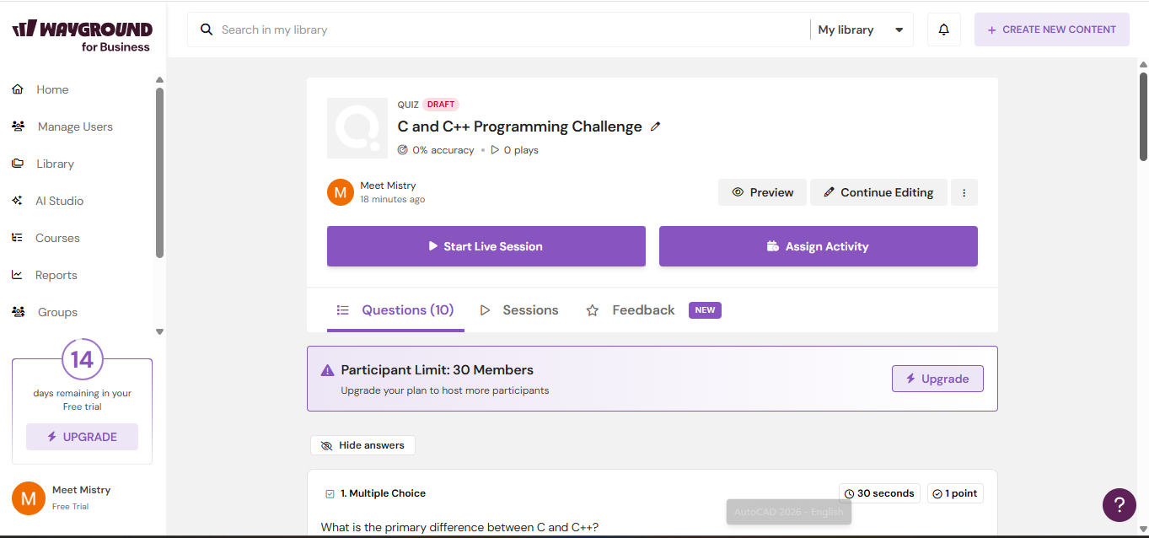

**Step 9: now here are some editable options if you want to use like hide the answers from audience, or shuffle the questions for all, etc..**

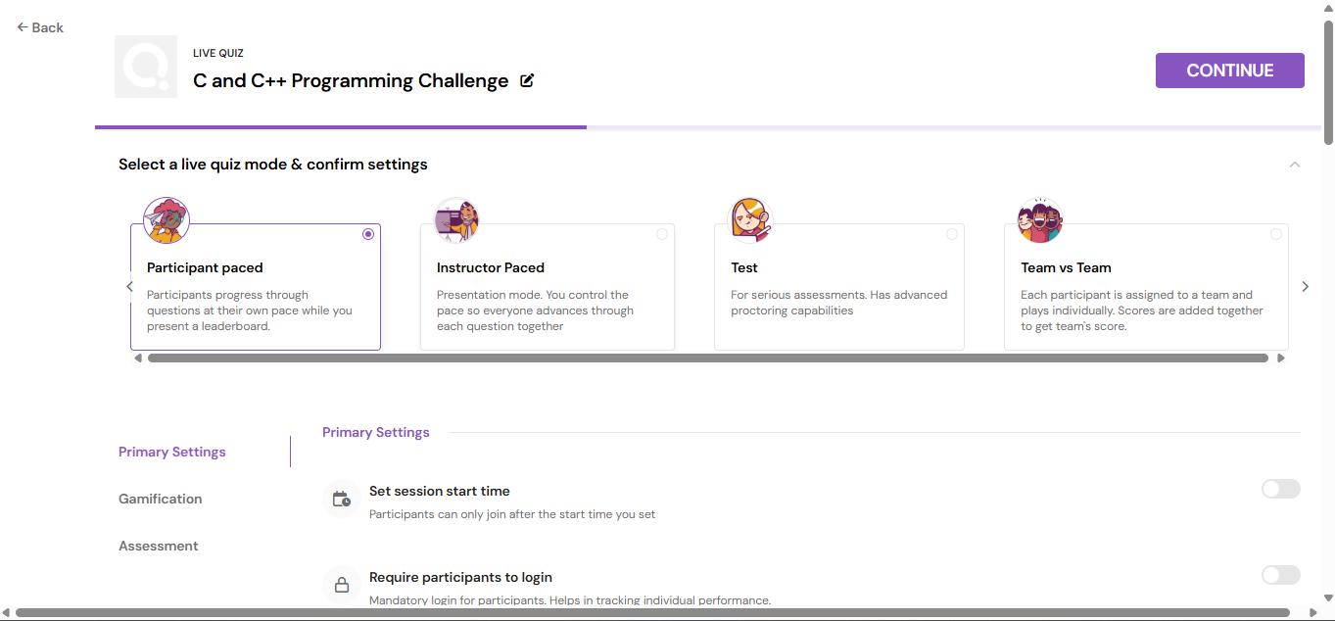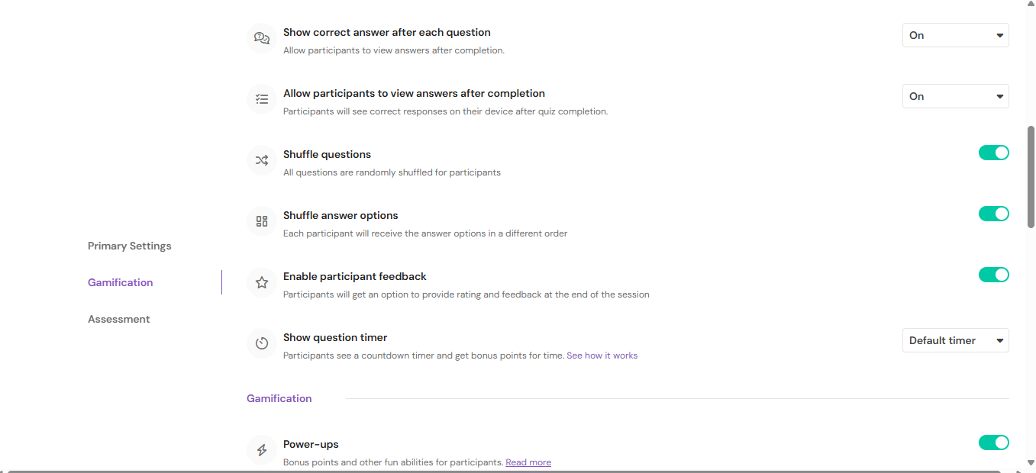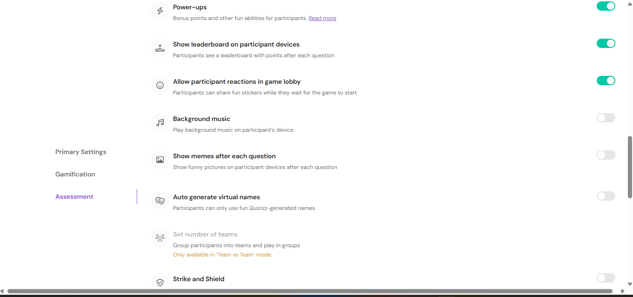

**Step 10: Once you have edited and ready to generate your quiz to audience just click to the START NOW.**

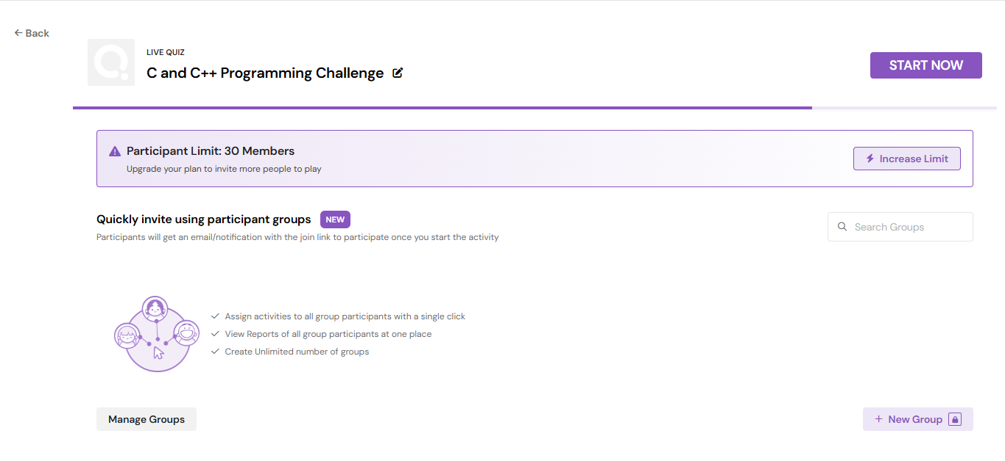

**Step 11: after start now u can see this interactive dashboard type which means your quiz is now published where user can scan their QR code or write the game pin to enter into your quiz.**

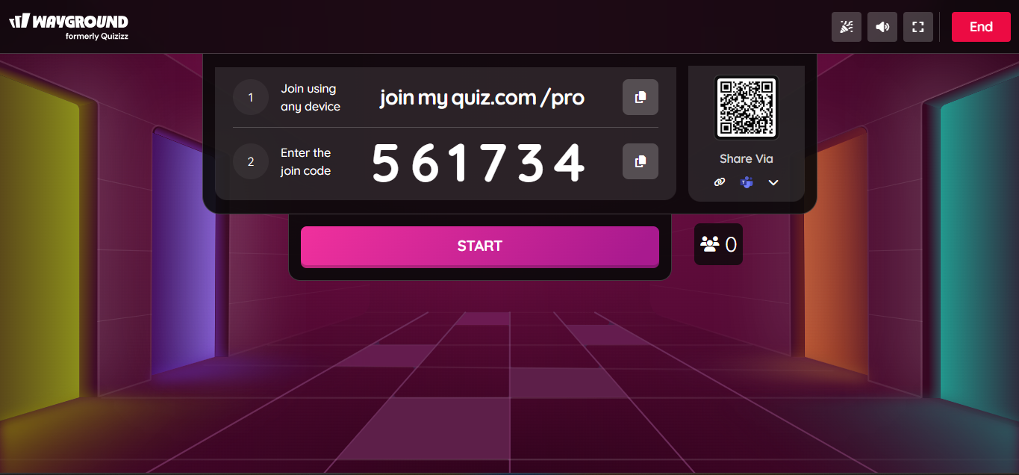

**Step 12: Here you can see 2 participants are enrolled in the quiz...**

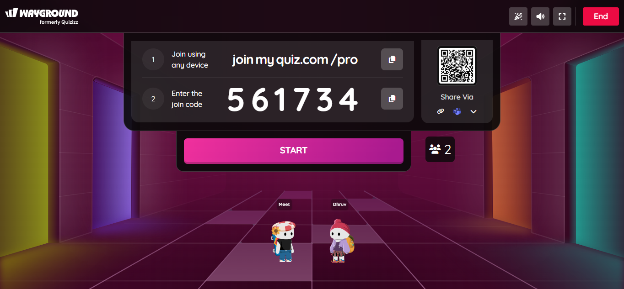

**Step 13: we can even check the activity status of the participants like who is leading, what question they have attempted wrong or write everything…**

